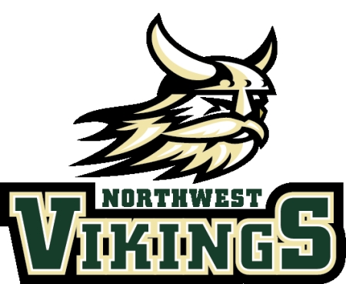

Department
of Choral Activities

Event Dates Quick-Sheet
2017-2018

August 18th Handbook/Calendar Acknowledgment Form Due
August 18th Parent Information Form Due
August 28th Required Parent Meeting for All Choirs

September 1st-15th Butter Braids Fundraiser
September 12th Viking Apollo – Open Mic Night
September 14th Deadline for Registration: Mid-State
September 14th Welcome Home Veterans Event (FBC Clarksville)
September 22nd Music, Choir, and Attire Fees Due

October 3rd Fall Choir Concert (Northwest High School)
October 18th APSU Choir Festival
October 19th-21st Mid-State Auditions (Siegel High School)

November 5th-6th Quad-State Choir Festival (Murray State University)
November 13th-14th Mid-State Event
November 17th-18th Montgomery County Honor Choir

December 7th Holiday Choir Concert (Northwest High School)

January 27th All-State 2nd Tier Auditions (Siegel High School)

February 26th-1st High School Choir Festival (FUMC, Murfreesboro)

March 2nd High School Choir Festival (Snow Date Only)

April 2nd Deadline for Registration: MTVA Solo and Ensemble
April 6th-7th CMCSS Honor Choir
April 11th-14th All State
April 19th Cabaret (Northwest High School)
April 20th Cabaret (Northwest High School)
April 22nd Cabaret (Northwest High School)
April 25th-26th ACDA State Choral Festival

May 5th MTVA Solo and Ensemble Festival
May 8th Spring Choir Concert (Northwest High School)

